**Basics - How To Use Your Server’s Console**

Hello! Welcome to SyteSpace, today i'm going to be running through your console basics!

**Step 1: Accessing Your Console.**

To access your console, all you need to do is navigate to your “My Servers” tab.  As shown below…https://lh6.googleusercontent.com/QmCWcu120jxFA4Ww17M3zSORr1U1I4vSAV487P6h9SJvAjSmhPiQ7ETLhKKzarmmoywD4y_J4keOiImlxZyVHgnbQLNSSFjB7onrKn4lC3Bl6m8kwKP_1ggwdVaa5j4_ae_k3pKA

Once you are here, you need to click on the blue text, where it says your server name. Once you have click on the blue text, you will be greeted with a page that looks similar to this…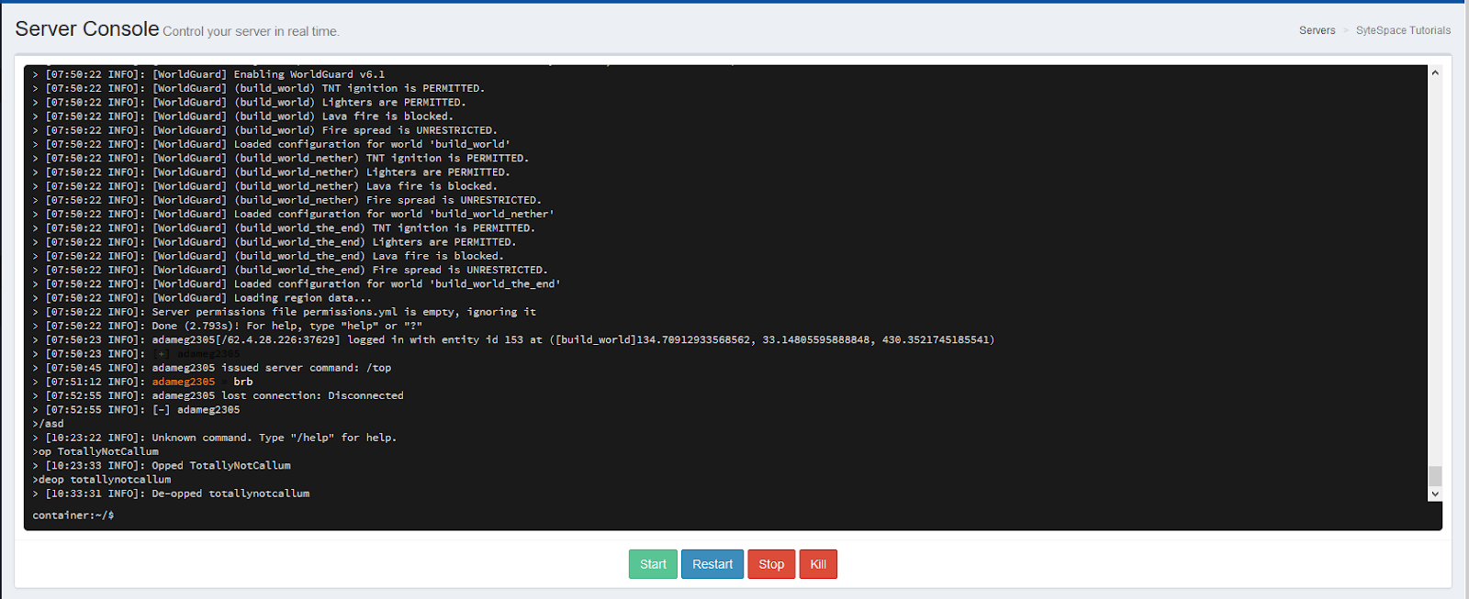

This is your server console! Here you can access, and type commands & control the status of your server!

**Step 2: Starting, Stopping, Restarting & Killing Your Server.**

Underneath your console screen *(The massive black window)* You can see 4 little buttons, these buttons all have a different purpose...

https://lh4.googleusercontent.com/LJDvHhKo2cNxFf022sbrF3ebxybv0zowkm0cF0-NLGdktiwhZGpliFyk155GPPjSnntffqUxeU0rjetCfEY-WOmArCxYoChzdqj2RHiQc66H0Kb9Uu_z014Nt8kxokniKEyTuLQF

The green “Start” button starts your server, if you are accessing your console for the first time, you will need to click this button!

https://lh6.googleusercontent.com/jc0FPCuOUDodme-gNS8-lQZIzeeBxjmo2Y6A8rlk4S4guoMjhNMBrBKrHc_ueLU2C5zVOyMyopa6uJCnUwusxHGLmPCkZx2KW-qeYGShCV74I-K9yLZfW-Ow20uQH5YIuDlj_YZN

The blue “Restart” button restarts your server, if you are adding plugins and want them to load, you will need to click this button!

https://lh4.googleusercontent.com/lcqxnOoSBb2h5m-4ALozpae7S4kPspNitaOSx79ooKF9lY2zkE5Eqy1SkV_naPCI3ubkbP00ThetVa-3Bjd863GhInJqb2QJT65ARYLbFp6NV9K59bKkcPLS6rRRcAWUcgpd-aTz

The red “Stop” button stops your server, if you are wanting to stop your server for any reason then you will need to click this button!

https://lh6.googleusercontent.com/oUqcjaV5apDUYXKXNKkacMlOi7hIJYaPiAh3Tjn-fzrVIBUJTFuImwX3i1rucU61ZucxVg6601gynlBfOu2xzAvf4d02_PiUXibr5vA4fN6bzPNxQdTIARfYeIlEBGkAQ3gdvZ6x

This other red button “Kill” will stop your server **IMMEDIATELY** here at SyteSpace we wouldn’t suggest pressing this button unless your server    crashed and or isn’t responding. Pressing this button could mess with your server files and could lead to some of your files being corrupted.

**Step 3: Accessing Your Server’s Console.**

The massive black window that you can see on your screen is your server’s console! In the console you can type most of the commands, without needing extra permissions.

To type in console just click the bottom bit where is says “container:~/$“ and type your command you wish to issue!

**Extra Info:**

At the bottom of your console you should see two different graphs, these graphs are used to monitor you server’s ram & cpu usage…

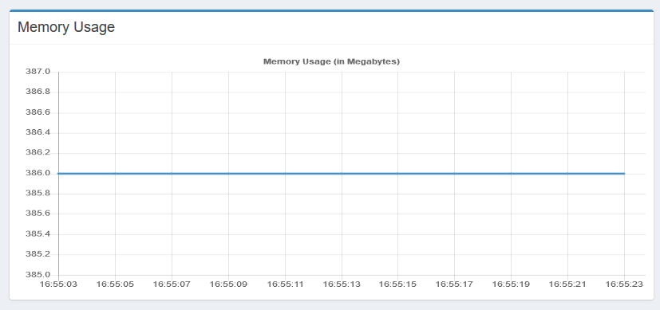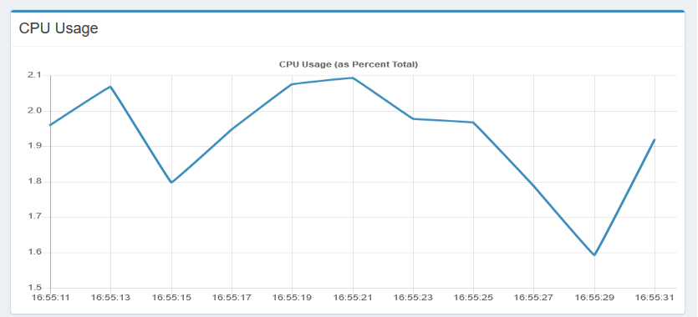

These graphs are not that important, it's simply just for your own knowledge. If you do experience CPU & RAM usage problems, be sure to contact support!

**Need Extra Help?**

And that concludes this Walk-Through…

If you need any more further assistance be sure to tag @Support in the SyteSpace discord #support channel!

My Discord @ Is Callum#1273 if you wish to contact me directly.

**SyteSpace Discord:**  https://www.discord.io/SyteSpace